[COURSE/CLUB NAME]   
  
**Employee Incident**

____ In emergency call 911

____ If seeking medical attention, Give two (2) copies of “Attention Injured Worker and Medical Provider” form to the employee

____ Instruct employee to give one to Medical Center for billing

____ Instruct employee to give one to Pharmacy for billing

____ Call (855)775-PUTT

____ Report #______________________________________________________________________

­­­­____ Fill out the “Claimant Statement Report”

____ If refusing medical attention, fill out “Refusal of Emergency Medical Transport or Aid Form”

____ Separate and flag any cart involved for Mechanic to fill out the “Golf Cart/Utility Vehicle Safety Inspection Report” (if cart was involved)

____ Have any witnesses write down a statement while it’s still fresh

____ Take detailed pictures of area

____ Take detailed pictures of any carts involved

____ An employee who seeks medical care **cannot return to work without bringing a Work Status** from the medical provider.

____ Send the Work status to Risk Management: [tdelacruz@centurygolf.com](mailto:tdelacruz@centurygolf.com)

____ If released with restrictions please do your best to accommodate (see alternative job duty list)

_____ If continued medical care is needed, the employee has to bring a new Work Status after every appointment.

_____ If the employee has lost time please notify Risk Management.

____ If **lost time is over 5 days complete an ESC form** (human resources) and send a copy to **Rafael Rios in HR** [rrios@centurygolf.com](mailto:rrios@centurygolf.com) and risk management. This will stop payroll and WC Lost Time benefits will pay the salary (insurance Carrier).

[COURSE/CLUB NAME]   
**Witness Statement**

Name of witness _________________________________________________________________________

Phone number ______________

*Initial when each line is finished*

____ In emergency call 911

____ If seeking medical attention, Give two (2) copies of “Injury Reporting Procedures” to person

____ Instruct employee to give one to Medical Center _____________________________________________________________

Date ____________________________________________________________________________________

__________________________________________________________________________________________

__________________________________________________________________________________________

__________________________________________________________________________________________

__________________________________________________________________________________________

__________________________________________________________________________________________

__________________________________________________________________________________________

__________________________________________________________________________________________

__________________________________________________________________________________________

__________________________________________________________________________________________

__________________________________________________________________________________________

__________________________________________________________________________________________

__________________________________________________________________________________________

__________________________________________________________________________________________

__________________________________________________________________________________________

__________________________________________________________________________________________

__________________________________________________________________________________________

__________________________________________________________________________________________

Century Golf Partners Management



**MEDICAL INSURANCE & PRESCRIPTION FORMS**

**(Give employee 2 COPIES)**

**ATTENTION MEDICAL PROVIDER: Please FAX a WORK STATUS to Tawny DeLaCruz at 1-888-772-8802**

**NOTE:**  **Receipt and use of this form does not constitute acceptance of a workers’ compensation claim – that will be determined by Sompo claims case specialist.**

Employee Name: _________________________________________________________________

Date of Injury: _________________________________________________________________

Employer Name: _________________________________________________________________

Employer Contact: ____Tawny DeLaCruz, Director, Risk Management & Safety_________________

Employer Phone: ____940-435-4873___________________________________________________

WC Policy Number: _Client #017436 Policy: WCDS1107H0__________________________________

**5-Panel Drug-Screen Required: _________YES _________NO**

***Yes - If had it not been for employee action or inaction, incident would not have happened.***

***No - If it would have occurred regardless of any action or inaction***

|  |
| --- |
| **Medical Billing & Contact Information**  Medical bills should be directed to:  **Sompo Global Risk Solutions Adjusting Unit**  PO Box 2971  Clinton, IA 52733-2971  **All Requests for Authorization(s) should be faxed to: 717-697-1402**  **Prescription Program**  ***Attention Medical Provider:*** *If the patient requires medication for their work- related injury, please write a prescription that the patient can take to the nearest pharmacy. It will be filled with no out of pocket expense.*  Workers Employer participates in **GBCARE**, a pharmacy benefit program administered by **Cadence RX. For assistance, call Cadence RX:** 1-888-813-0023  RX PROGRAM ADMINISTERED**: Cadence RX** Group Number**: VXRQZY** PCN Number**: CRX**  BIN Number: **021460** Employer Name: **Century Golf Partners Management, LP**  Client Number: **017436** |

WORKERS’ COMPENSATION PRESCRIPTION INFORMATION

# Employer:

Please fill out the employee information below and provide the employee with this document to take to any pharmacy for their Workers’ Compensation prescriptions.

# Employee:

**Gallagher Bassett** has partnered with **Cadence Rx** to make filling workers’ compensation prescriptions easy. Medications may be subject to formulary and pre-authorization requirements.

**This document serves as a temporary prescription card. A permanent prescription card specific to your work-related injury or illness will be forwarded directly to you within the next 3 to 5 business days.**

Please take this letter and your prescription(s) to a pharmacy near you. Cadence Rx has a network of over 72,000 pharmacies nationwide. To locate a network pharmacy near you, please use the pharmacy locator at [http://cadencerx.com/find-a-](http://cadencerx.com/find-a-pharmacy/) [pharmacy/](http://cadencerx.com/find-a-pharmacy/) or call Cadence Rx toll-free at 1-888-813-0023.

**IF YOU HAVE QUESTIONS OR NEED ASSISTANCE AT THE PHARMACY, PLEASE CALL 888-813-0023**

# Pharmacist:

Please obtain the below information from the injured employee if not already filled in by the employer to process prescriptions for the workers’ compensation injury only.

For questions or rejections, please call 1-888-813-0023. Please do not send the patient home or have the patient pay for medication(s) before calling Cadence Rx for assistance.

**Note: Certain medications are pre-approved for this patient; these medications will process without an authorization. All others will require prior approval.**

|  |  |  |
| --- | --- | --- |
| Prescription Drug ID Card | | Pharmacy Information |
|  | | This form allows you to fill your initial prescriptions with a maximum cost of $300 per medication and no more than a 14-day supply per prescription. Pharmacy, if you need assistance processing this claim, please call 1-888-813-0023.  The pharmacy benefit card is only to be used for medications prescribed for your work-related injury. By using this card, you acknowledge and accept financial responsibility for any prescriptions billed under this card that are later found to be unrelated to your injury.   * **Member ID format: The ID must start with FF followed by the last 4 digits of the social security number plus 8- digit DOI (MMDDYYYY). Example: FF999901012018** |
| **Employee Name:** |  |
| **Member ID**  **Number\*** | **\*Refer to Member ID**  **Format** |
| **Date of Injury:** |  |
| **Group Number:** | **VXRQZY** |
| **PCN Number:** | **CRX** |
| **BIN Number:** | **021460** |
| **Card Created On: / /** | |

WORKERS' COMPENSATION PRESCRIPTION INFORMATION

# .Empleador:

Complete la informaci6n del empleado a continuaci6n y proporcione al empleado este documento para que lo lleve a cualquier farmacia para sus recetas de compensaci6n para trabajadores.

# Empleado:

**Gallagher Bassett** se ha asociado con Cadence Rx para facilitar el surtido de recetas de compensaci6n para trabajadores.

**Este documento sirve como tarjeta de prescripcion temporal. Se le enviara directamente una tarjeta de prescripcion permanente espedfica para su lesion dentro de los proximos 3 a 5 dias habiles.**

Lleve esta carta y su(s) receta(s) a una farmacia cercana. Cadence Rx tiene una red de mas de 72,000 farmacias en todo el pafs. Para ubicar una farmacia de la red cerca de usted, use el localizador de farmacias en [http://cadencerx.com/find-a­](http://cadencerx.com/find-a) pharmacy/ o Ilame gratis a Cadence Rx al 1-888-813-0023.

**SI TIENE ALGUNA PREGUNTA O NECESITA AVUDA EN LA FARMACIA, LLAME AL 1-888-813-0023**

# Farmaceutico:

Obtenga la siguiente informaci6n del empleado lesionado si aun no la ha completado el empleador para procesar las recetas solo para la lesion de compensaci6n del trabajador.

Si tiene preguntas o rechaza, Ilame al 1-888-813-0023. Por favor no envfe al paciente a casa ni haga que el paciente pague por los medicamentos antes de Ilamar a Cadence Rx para solicitar ayuda.

**NOTA: Ciertos medicamentos estan preprobados para este paciente; estos medicamentos se procesaran sin una autorizacion. Todos los demas requeriran aprobacion previa.**

**PARA CUALQUIER PREGUNTA O AVUDA CON APROBACIONES DE MEDICAMENTOS, LLAME AL: 1-888-813-0023**

|  |  |  |
| --- | --- | --- |
| Tarjeta de identificaci6n de medicamentos recetados | | lnformaci6n de farmacia |
|  | | Este formulario le permite surtir sus recetas iniciales con un costo maxima de $300 por medicamento y un suministro de no mas de 14 dfas par receta. Farmacia, si necesita ayuda para procesar este reclamo, llame al 1-888-813-0023.  La tarjeta de beneficios de farmacia solo debe usarse para medicamentos recetados para su lesion relacionada con el trabajo. Al usar esta tarjeta, usted reconoce y acepta la responsabilidad financiera por cualquier receta facturada con esta tarjeta que luego se descubra que no esta relacionada con SU lesion.  **Formato de identificacion de miembro: la identificacion debe comenzar con FF seguido de los ultimas 4 digitos del**  **numero de seguro social mas la fecha de la lesion de 8 digitos (MMDDYVVV). Ejemplo: FF999901302018** |
| **Nombre del Empledo:** |  |
| **No de ID de Miembro:\*** | * Consulte el formato  de identification de miembro |
| **Fecha de la lesion:** |  |
| **Nombre del Grupo:** | **VXRQZY** |
| **Numero PCN:** | **CRX** |
| **Numero BIN:** | **021460** |
| **Tarjeta creada el:** *J j* | |

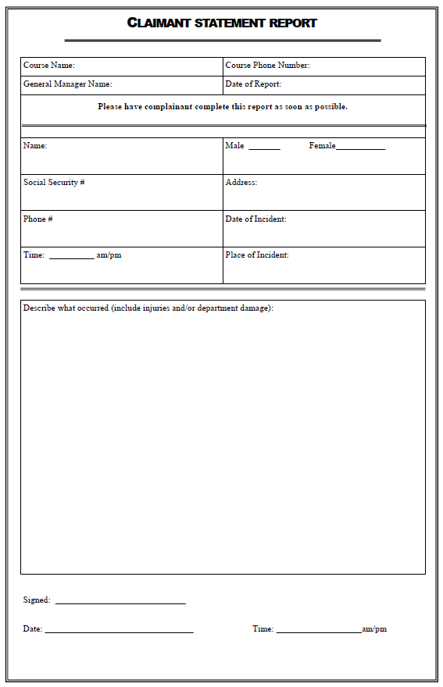



Refusal of Emergency Medical Transport or Aid Form

Note: Only the involved party, parent, or legal guardian of at least 18 years old may complete this form.

(Incident Date) (Incident Time)

**Location of Incident**

(Street Address)

(City) (State) (Zip Code)

**Incident and Injury Description**

**Involved Party**

(Name) (Age)

(Residential Address)

(City) (State) (Zip Code)

(Email) (Phone Number)

Parent or Legal Guardian, if any

(Name) (Age)

(Affiliation to Involved Party)

(Residential Address)

(City) (State) (Zip Code)

(Email) (Phone Number)

By signing below, the involved party (Parent or Legal Guardian) certifies that:

1. They are an adult (over 18 years of age).
2. They are oriented to Person, Place, Time, and Situation.
3. They do pose a danger to any other person in their current condition.
4. They are competent to make sound decisions relative to the care of themselves (or involved parties).
5. They understand the nature and extent of their (or the involved party’s) medical condition, as well as the risks, and consequences of refusing emergency medical transport or aid.

(Signature of Involved Party, Parent, or Legal Guardian) (Date) (Time)

(Print name of Involved Party, Parent, or Legal Guardian)

(Witness Signature) (Date) (Time)

(Print Name of Witness)

(Witness Affiliation or Title)