**Customer Incident**

*Initial when each line is finished*

____ In emergency call 911

____ Call (855)775-PUTT

____ Report #______________________________________________________________________

­­­­____ Fill out the “Claimant Statement Report”

____ If refusing medical attention, fill out “Refusal of Emergency Medical Transport or Aid Form”

____ Separate and flag any cart involved for Mechanic to fill out the “Golf Cart/Utility Vehicle Safety Inspection Report” (if cart was involved) and send to Risk Management along with maintenance records.

____ Have any witnesses write down a statement while it’s still fresh – type of shoes they were wearing, intoxicated, were they distracted (i.e. on cell phone), and substance on ground, anything that is negligent on our end. These details should be included, especially by the employees responding to the incident.

_____ If faulty furniture or equipment contributed to the incident, remove service/use and place in storage. Put a note on the item “Do Not Use or Dispose” and your name and date. The item must stay in storage until approved by Risk Management it can be disposed of.

____ Take detailed pictures of area and any injuries IMMEDIATELY

____ Take detailed pictures equipment involved and then save for inspection

____ Release of Liabilities/Member applications will need to be sent to Risk Management

____ Respond within 24 hours of the incident to Risk Management questions

____ If injured, follow up the next day and do a well check.

Name of injured guest _________________________________________________________________

Date ____________________________________ Time of incident ________________________________

Your name _______________________________________________________________________________

[COURSE/CLUB NAME]   
  
**Witness Statement**

Name of witness _________________________________________________________________________

Phone number ___________________________________________________________________________

Date ____________________________________________________________________________________

__________________________________________________________________________________________

__________________________________________________________________________________________

__________________________________________________________________________________________

__________________________________________________________________________________________

__________________________________________________________________________________________

__________________________________________________________________________________________

__________________________________________________________________________________________

__________________________________________________________________________________________

__________________________________________________________________________________________

__________________________________________________________________________________________

__________________________________________________________________________________________

__________________________________________________________________________________________

__________________________________________________________________________________________

__________________________________________________________________________________________

__________________________________________________________________________________________

__________________________________________________________________________________________

__________________________________________________________________________________________

__________________________________________________________________________________________

__________________________________________________________________________________________

__________________________________________________________________________________________

__________________________________________________________________________________________

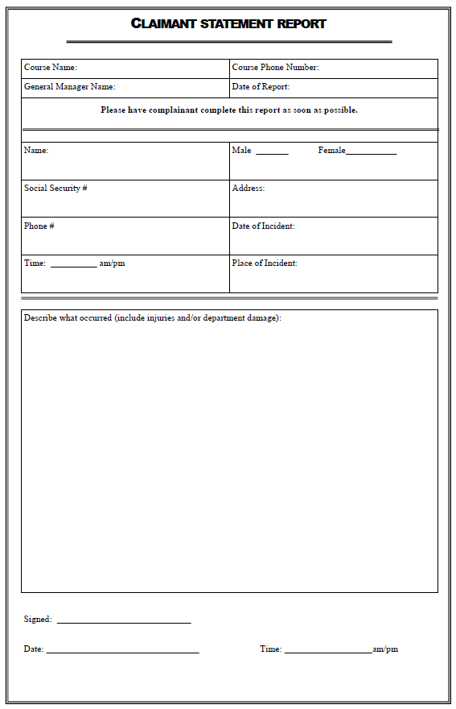



Refusal of Emergency Medical Transport or Aid Form

Note: Only the involved party, parent, or legal guardian of at least 18 years old may complete this form.

(Incident Date) (Incident Time)

**Location of Incident**

(Street Address)

(City) (State) (Zip Code)

**Incident and Injury Description**

**Involved Party**

(Name) (Age)

(Residential Address)

(City) (State) (Zip Code)

(Email) (Phone Number)

Parent or Legal Guardian, if any

(Name) (Age)

(Affiliation to Involved Party)

(Residential Address)

(City) (State) (Zip Code)

(Email) (Phone Number)

By signing below, the involved party (Parent or Legal Guardian) certifies that:

1. They are an adult (over 18 years of age).
2. They are oriented to Person, Place, Time, and Situation.
3. They do pose a danger to any other person in their current condition.
4. They are competent to make sound decisions relative to the care of themselves (or involved parties).
5. They understand the nature and extent of their (or the involved party’s) medical condition, as well as the risks, and consequences of refusing emergency medical transport or aid.

(Signature of Involved Party, Parent, or Legal Guardian) (Date) (Time)

(Print name of Involved Party, Parent, or Legal Guardian)

(Witness Signature) (Date) (Time)

(Print Name of Witness)

(Witness Affiliation or Title)