**Spill Cleanup Products**

Employees need to understand that spill cleanup should occur immediately. Utilizing the spill clean-up products below, including use of wet floor signs, will assist in addressing this exposure in a timely manner, even during periods of high volume.

**Over The Spill Pads**

Over the Spill pads simultaneously create high visibility by their design (Caution) while also effectively absorbing the liquid and improving the slip resistance. These are great to utilize when a spill occurs, but staff cannot immediately clean up the spill. These can easily be stored by drink stations, next to walk-in coolers, and other areas where spills are common.

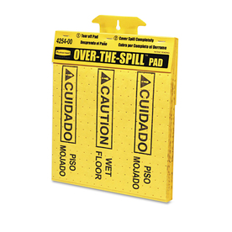 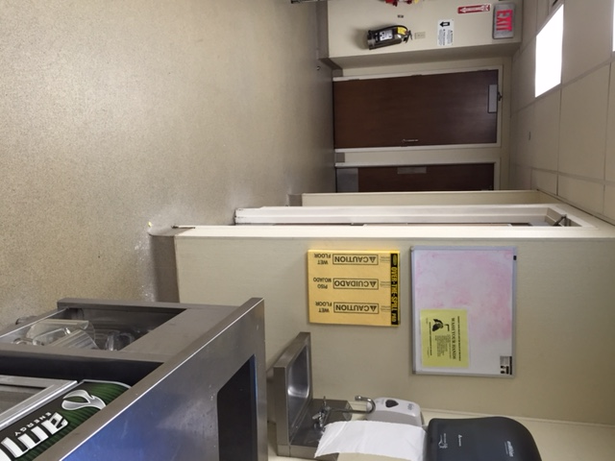

**Wypall Towels**

Wypall towls compliment the over-the-spill pads by providing an alternative, cost-effective product to help with immediately cleaning up of spills.



**Both towels can be used for immediate spill clean-up and can be discarded easily.**